St Peter Catholic Church Honduran Mission Circle Water Project

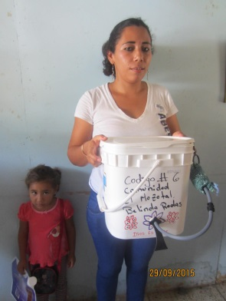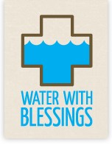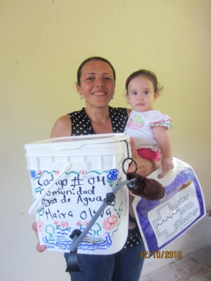

Our Mission: We are mothers & missionists bringing clean water to God's thirsty children.

As mission partners of Water with Blessings, we equip and empower mothers to become Water Women: compassionate agents of change in their communities, who filter clean water for their families and neighbors.
Water Women are... mothers living in marginal communities of developing nations, offering an act of compassion to our neighbors by filtering their drinking water.
They are Water Teachers and Leaders... experienced Water Women who serve as trainers for new Water Women and support the ministry in their communities to ensure it is carried out in accord with the WWB ministry.
We are Mission Partners and Advocates.
We... could be YOU! We invite you to join the WWB Community. We offer you a uniquely effective way to respond to the world-wide water crisis.
The Solution is an inexpensive, home-based filtration system, a willing community and YOU.
Using technology inspired by our own biology, the Sawyer PointONE filter system functions much like kidney dialysis does to filter out impurities in the water, leaving clean, drinkable water in 5 minutes.

... and mothers and their communities…
We have learned that mothers are ideal partners in our quest to change the reality of dirty water in marginal communities. We invite them to make a faith-based commitment. To become Water Women, mothers attend a training that is both spiritual and practical. They sign a covenant, a sacred commitment to God and their community that they will use their filters to serve others. Then they go forth to love and serve their God and neighbor through a daily, life-saving ministry of filtering water. What better witness could they be?
Cool! So, how can you help?

- Donate filters for yourself or in lieu of gifts to or in memory of family or friends
- Pray for us to continue to receive the necessary support to bring clean water to our Sister Parish Community
- Ask for materials to present to a group or invite us to present at an upcoming meeting. For more information, please contact Gini Eckert at 386-736-2211.

