<EMPTY><EMPTY>

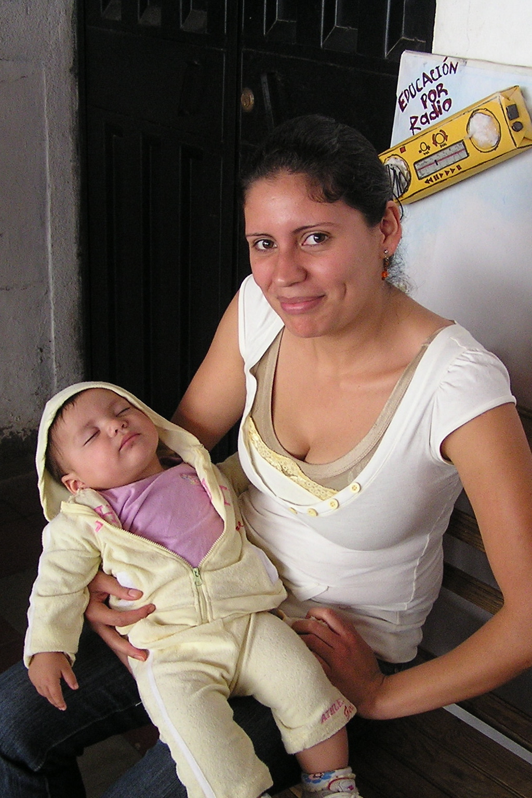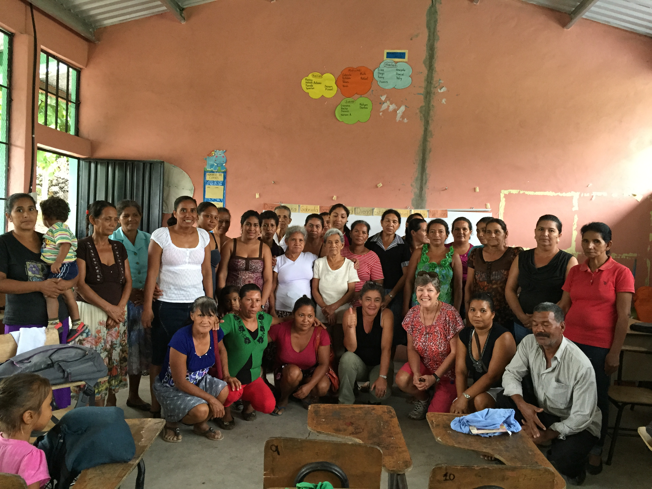

Women’s Project

A Micro-loan Program for Underprivileged Women and Their Children in Sabanagrande, F.M., Honduras

*sponsored by St. Peter Mission Circle

*similar to Grameen Bank Micro-Credit Program

*developed by Fr. Joaquin, 10 years experience with micro-loans in Africa

*administered by Fr. Andres, pastor of Our Lady of the Rosary

*

I would like to

🗒 make a donation of $_____ (any amount).

🗒 sponsor ____ woman/women for $300 each.

🗒 I would like to receive a card or cards that I can use as a gift (birthday, Christmas, anniversary) or for a

memorial.

Name _______________________________________________________________________________________

Address _____________________________________________________________________________________

Phone ____________________ Email ____________________________________________________________

For more information call Gini at 386-736-2211.

How can you help?

Choose one of 2 options: make a donation or sponsor a woman.

WHAT: Each woman plans a business and receives a loan of $300 for 6 months. After 6 months, she saves 10%, repays the loan with interest, and receives a new loan for $300. This cycle is repeated until, in 5 years, she has saved $300 and is self-sufficient. The women are organized in groups which are responsible collectively for the debts of their circle. An admistrator, paid by the interest, oversees and counsels the women.

WHO: underprivileged women and their children

WHEN: started in 2011with 236 women, currently funding 585

WHY: To break the cycle of poverty, to help these women to create lives for themselves and their children.

WHERE: Sabanagrande, F.M., Honduras,

Our Lady of the Rosary



 